**Lab Program Number: 3 Date: 2082-03-17**

**Title: OS Installation and Practice on Basic Networking Commands**

**THEORY:**

**Linux**

Linux is a free and open-source operating system that is based on Unix. It acts as a bridge between a computer’s hardware and the software applications users run. It is known for its stability, security, and flexibility. Linux is widely used in various environments from personal computers and mobile devices to servers and supercomputers. Linux is especially popular for running web servers and powering devices like routers, TVs, and smartphones. User can modify its source code, and popular distros include Ubuntu, Fedora, and Debian.



Fig: Linux OS

**Virtual Box**

VirtualBox is a free and open-source virtualization software developed by Oracle. It allows users to run multiple operating systems on a single physical machine by creating virtual machines (VMs). It supports various host platforms like Windows, macOS, Linux, and Solaris, making it a versatile choice for developers, students, and IT professionals.

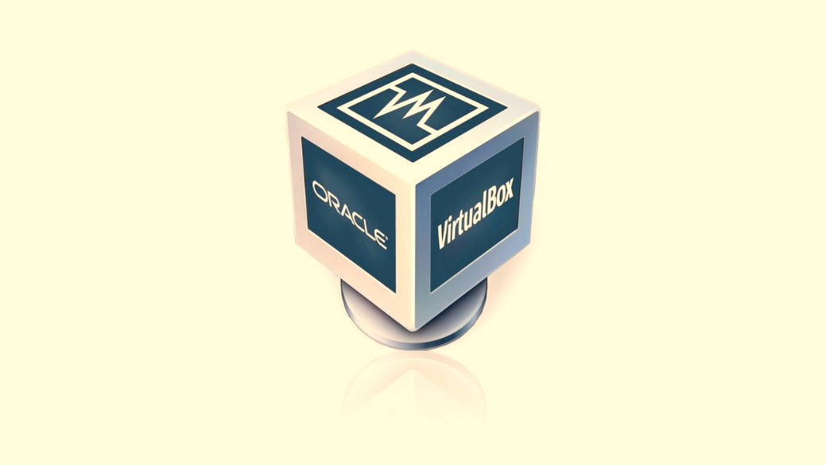

Fig: Virtual Box

**VMware**

VMware refers to a suite of virtualization products developed by VMware Inc., with VMware Workstation (for Windows and Linux) and VMware Fusion (for macOS) being the most used desktop virtualization tools. It is known for its robust performance, advanced features, and enterprise-level capabilities, such as better hardware integration and snapshot management

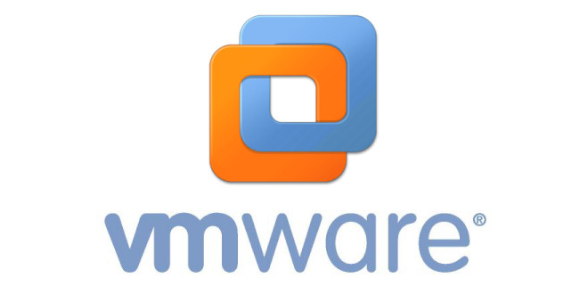

Fig: VMware

**Installing Virtual Box:**

Installing VirtualBox lets you run multiple operating systems at once by creating virtual machines on your computer. This is useful for testing software, developing programs, or trying out different operating systems without making any changes to your main system.

Here, Click Next and Proceed

After Virtual Box is installed, we get the interface like this,

Once Virtual Box is installed, we can create, add or import new VMs using toolbar buttons.

**Installing Linux (Ubuntu) Desktop OS:**

**Step 1:** Click New on Virtual Machine toolbar and add details about the new VM and required OS.

**Step 2:** Set the username, password, and hostname for the guest operating system

(Ubuntu) that will be installed in VirtualBox, then click "Next" to proceed.

**Step 3:** Modify the Base Memory and Processors to be allocated to the virtual Machine according to your PC capacity.

**Step 4:** Click New on Virtual Machine toolbar and add details about the new VM and required OS.

**Step 5:** This is the interface of the newly created Virtual Machine for Ubuntu Desktop OS. Choose the Server option and click Start to launch the Virtual Machine.

**Step 6:** Press Enter to Install Ubuntu Server.

**Step 7:** Choose your preferred language and click on next.

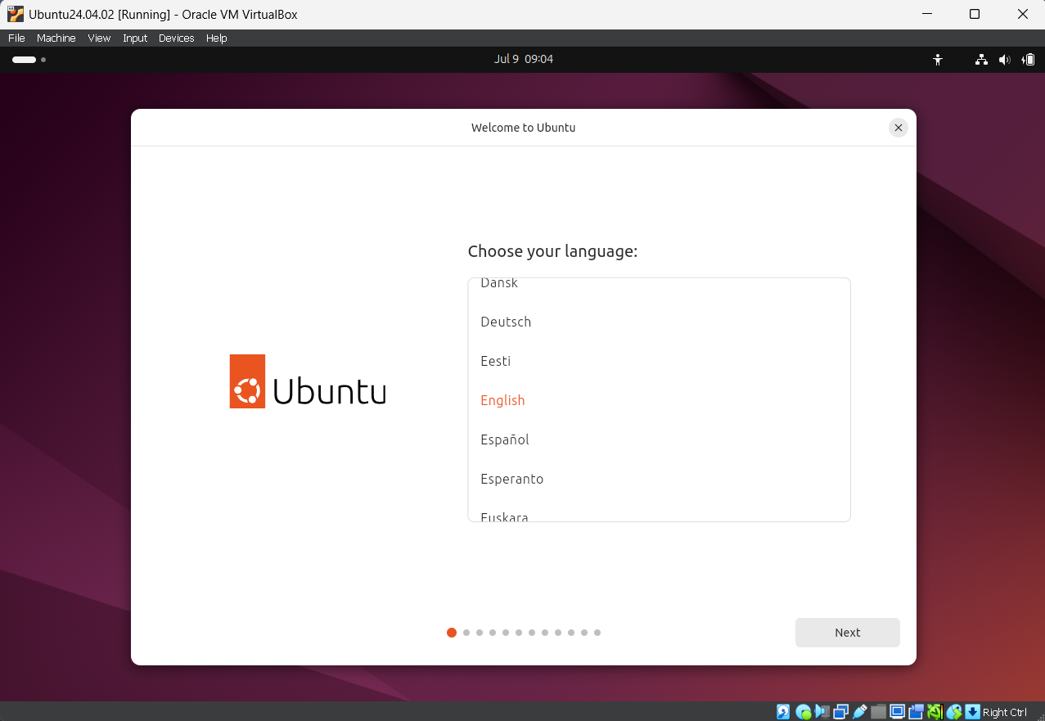

**Step 8:** Select the preferred Keyboard layout and click on next.

**Step 9:** Choose the interactive installation and proceed to next.

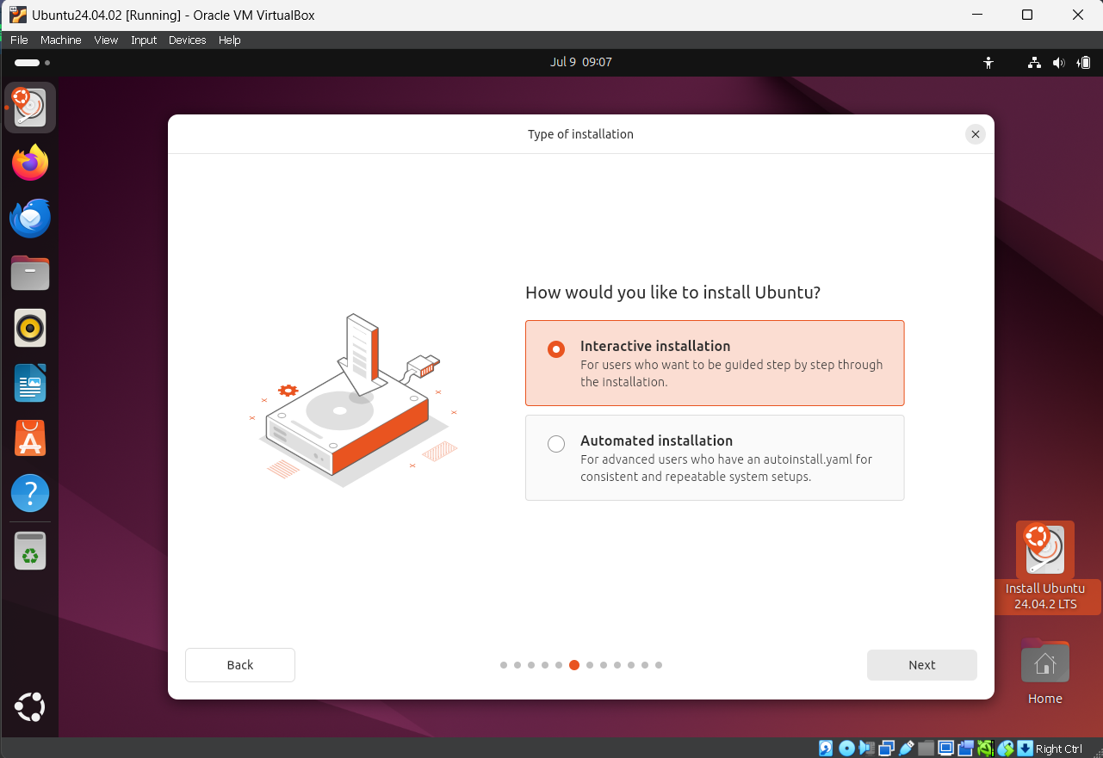

**Step 10:** Create an account and click on Next.

**Step 11:** Select your location and click on Next.

**Step 12:** After the completion of installation process, restart and login to your account.

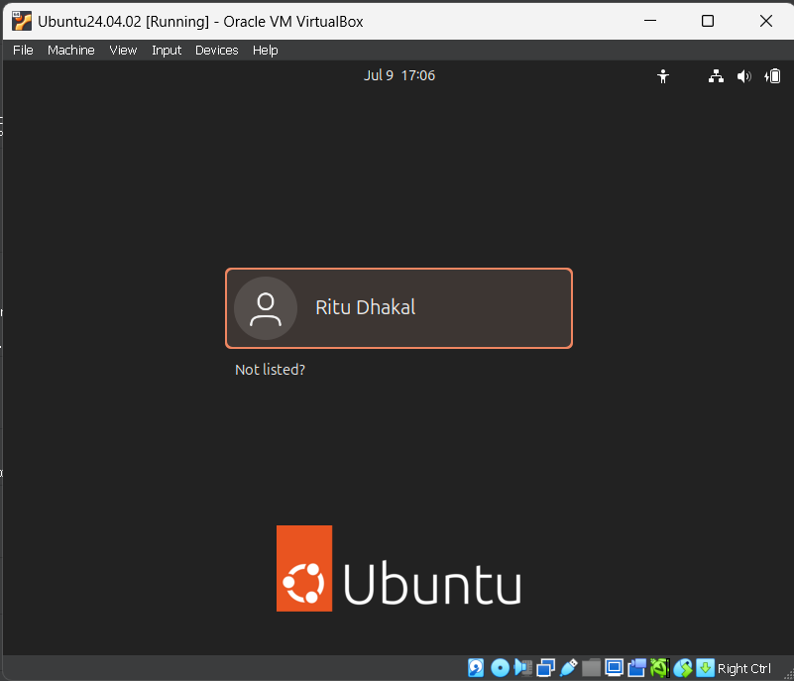

**Step 13:** Ubuntu is installed and our system interface looks like this:

Basic Networking Commands:

1. PING

PING (Packet Internet Groper) is a tool used to check if one computer can communicate with another over a network.

***Syntax:*** *ping <hostname or IP address>* (Windows & Linux)

**Use:** It helps verify whether a website or device is active and responding on the network.

Windows:

Linux:

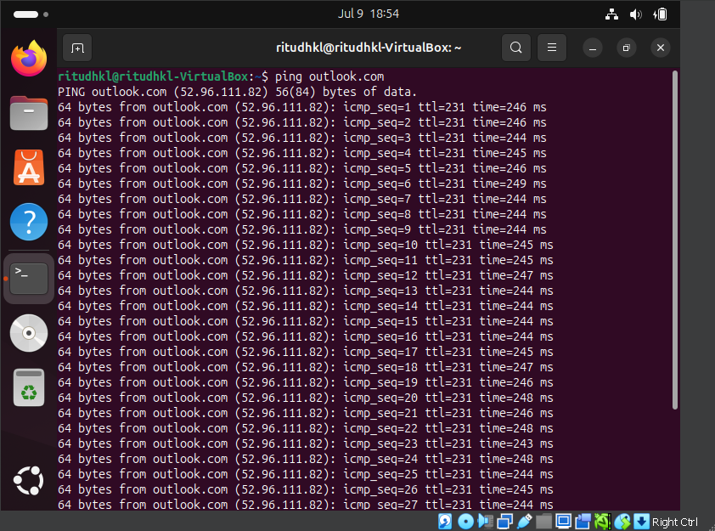

1. GETMAC

GETMAC is a command that shows the MAC (Media Access Control) addresses of your computer's network devices.  
***Syntax:*** *getmac*  
**Use:** Used to identify the physical address of the network adapter on your system.

1. HOSTNAME

The hostname command displays the name of your computer as recognized on a network. It's helpful for identifying your device in a local or connected network.

***Syntax:*** *hostname*

**Use:** Used to check the computer’s name on the network quickly.

Windows:

Linux:

1. IPCONFIG

Ipconfig (Internet Protocol Configuration) is a command-line tool used in Windows operating systems to view and manage network settings.

***Syntax:*** *ipconfig or ipconfig /all*  
**Use:** It displays details like the computer’s IP address, subnet mask, default gateway, and DNS servers, and can also be used to renew or release IP addresses.

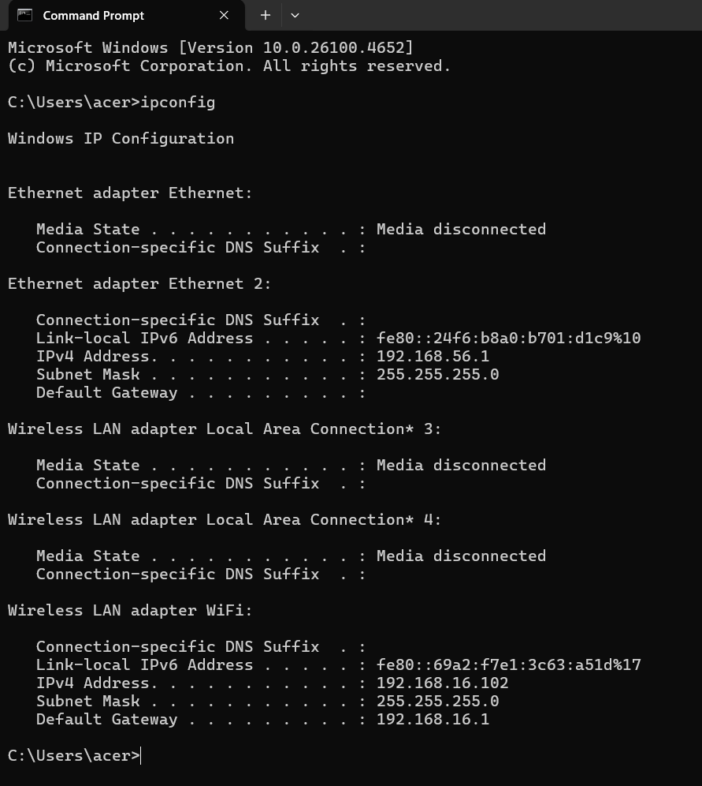

1. TRACERT

Tracert is a Windows command-line tool that shows the path data takes to travel from your computer to another device or website across a network.

***Syntax****: tracert [hostname or IP address]*

**Use:** Helps you find where slowdowns or connection problems happen as data moves through different servers on the way to its destination.

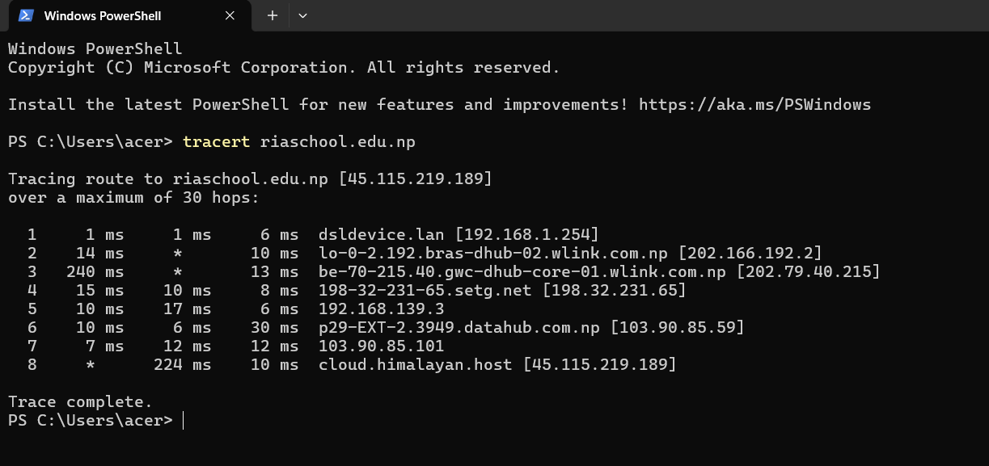

1. NSLOOKUP

NSLOOKUP is a command-line tool that lets you check DNS records by finding the IP address linked to a domain name or vice versa.

***Syntax:*** *nslookup <domain name>*

**Use:** Used to look up the IP address of a website or find the domain name from an IP address, helping with DNS troubleshooting and verification.

Windows

Linux

1. NETSTAT

Netstat is a command-line utility that shows current network connections, open ports, and protocol activity on your system.

***Syntax:*** *netstat* *(can be combined with options like -a, -n, -o for more details)*

**Use:** Used to monitor active internet or local connections, check which ports are in use, and troubleshoot network issues in real time.

Linux

Windows

1. Route

ROUTE PRINT is a Windows command that displays the system’s routing table, showing how data is directed between your computer and other networks.

***Syntax:*** *route print* (Windows)

*Route -n or ip route show* (Linux)

**Use:** Helps you see the network paths and gateways your computer uses to send data, which is useful for advanced troubleshooting and custom network setups.

Linux

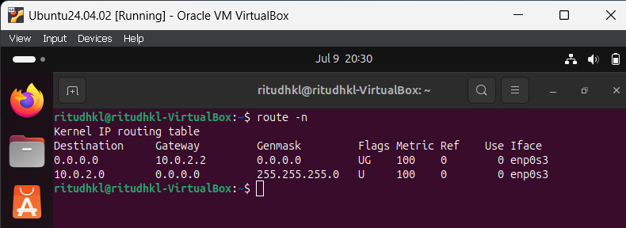

Windows

1. NMAP

NMAP is a network scanning tool used to find devices, open ports, and running services on a network. It’s commonly used for security checks and network audits.

***Syntax:*** *nmap <target IP or hostname>*

**Use:** Helps scan a system or network to discover active hosts, available services, and potential vulnerabilities.

Linux

1. NETCAT

NETCAT is a flexible command-line utility used to create and test network connections over TCP or UDP. It’s like a "Swiss Army knife" for networking tasks.

***Syntax:*** *nc [options] <hostname> <port>*

**Use:** Used for connecting to ports, sending or receiving data, scanning open ports, and debugging or testing services across a network

Linux

1. CURL

CURL is a command-line program that transfers data between your computer and a server using protocols like HTTP, HTTPS, FTP, and more.

***Syntax:*** *curl [options] <URL>*

**Use:** Commonly used to download files, test web APIs, or inspect server responses from websites and services.

Windows

Linux

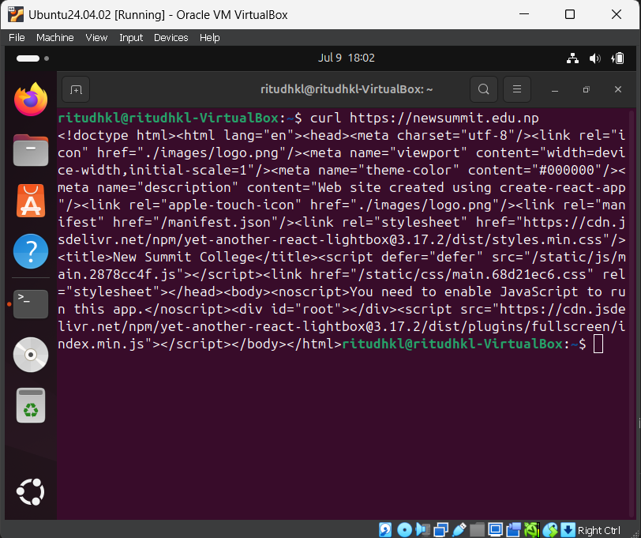

1. SYSTEMINFO

SYSTEMINFO is a Windows command that provides a detailed overview of your computer’s hardware, operating system, and configuration details.

***Syntax:*** *systeminfo (Windows)*

*uname -a or lsb_release -a*

**Use:** Used to view a comprehensive summary of your system’s specs like OS version, CPU, RAM, BIOS, and network info.

Windows

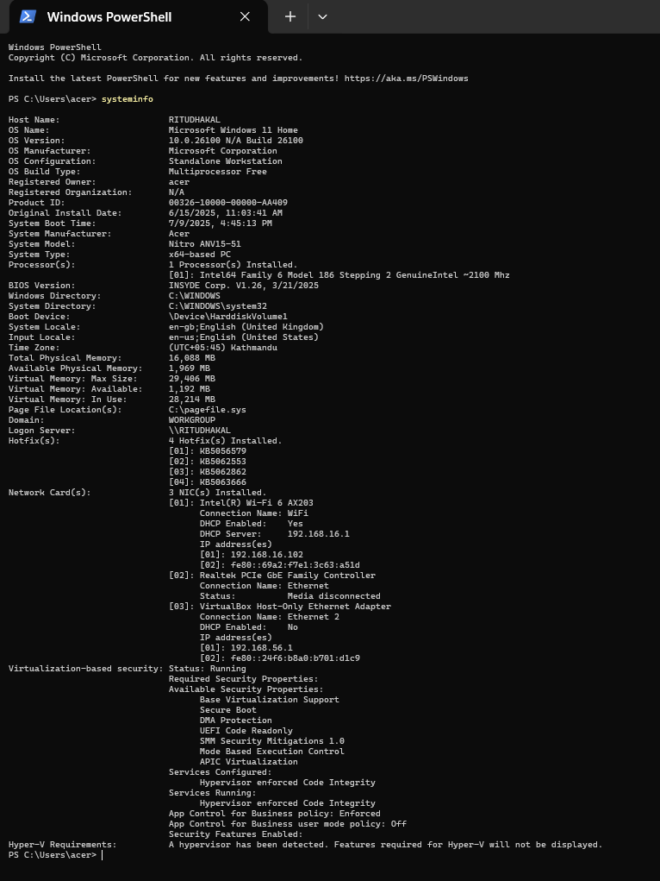

Linux

Conclusion

In this practical, we installed Ubuntu Linux using VirtualBox and explored VMware as another virtualization option. We set up a virtual machine, allocated resources, and completed the OS installation. We also practiced essential networking commands on both Windows and Linux, such as ping, ipconfig, tracert, netstat, nslookup, curl, and netcat, which help diagnose and troubleshoot network issues. This lab strengthened our skills in virtualization, OS installation, and basic networking, providing a solid foundation for system administration and network troubleshooting.